1. Here is a table with 6 rows and 3 Columns:

X Y Z

910 a1 b1

820 a2 b2

730 a3 b3

640 a4 b4

550 a5 b5

460 a6 b6

Put the data in .xlsx, .txt , .csv and read it using R Code.

**Answer:**

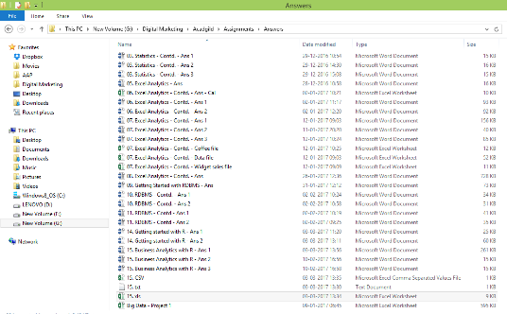

**CSV**

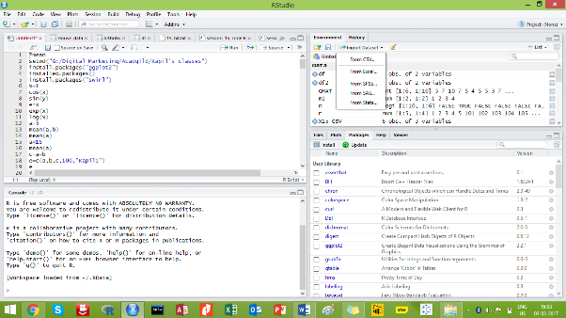

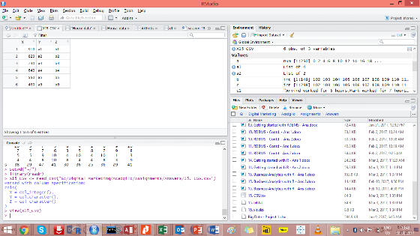

**XLSX**

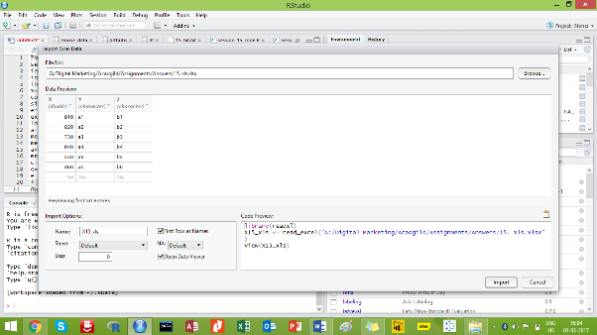

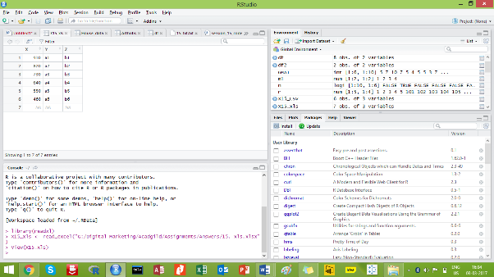

**TXT**

